Comilla university

Department of pharmacy

ASSIGNMENT ON

**HEPATIC DISEASE AND IT’S MANAGEMENT**

**Course code:** PHARM 5203

**Course title:** Drug and disease management |||

**Submitted by**

Tanjila Ahmed

*ID: 11915007*

*Session: 2018-19*

**Submitted to**

**Rafeza Khatun**

Assistant professor

Pharmacy dept, CoU

**Submission date: 08/12/2024**

**Hepatic Diseases: Etiology, Pathophysiology, and Management Strategies**

**Table of Contents**

1. **Introduction**
2. **Classification of Hepatic Diseases**
   * 2.1 Acute vs. Chronic Hepatic Diseases
   * 2.2 Common Types of Hepatic Diseases
   * 2.3 Risk Factors
3. **Pathophysiology of Hepatic Diseases**
   * 3.1 Cellular and Molecular Mechanisms of Liver Damage
   * 3.2 Progression of Liver Damage
4. **Diagnosis of Hepatic Diseases**
   * 4.1 Clinical Presentations and Symptoms
   * 4.2 Diagnostic Approaches
   * 4.3 Emerging Diagnostic Technologies
5. **Management of Hepatic Diseases**
   * 5.1 General Management Principles
   * 5.2 Pharmacological Treatments
   * 5.3 Surgical Interventions
   * 5.4 Disease-Specific Management
   * 5.5 Emerging Therapies
6. **Prevention and Public Health Perspectives**
   * 6.1 Preventive Strategies
   * 6.2 Screening Programs
   * 6.3 Health Policies
7. **Challenges in Hepatic Disease Management**
8. **Conclusion**
9. **References**

**Introduction**

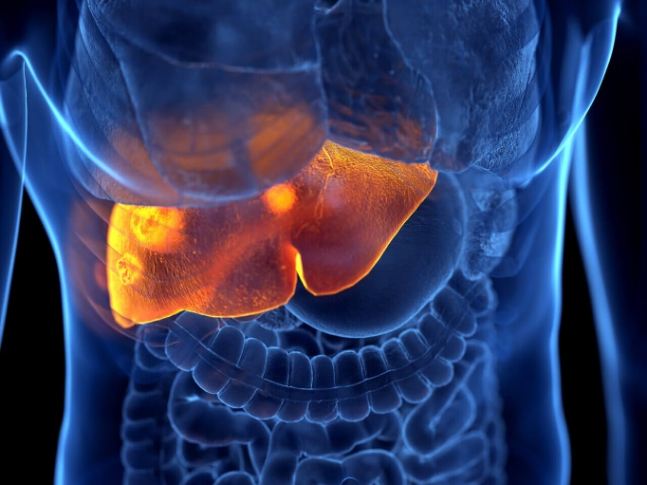The liver, the largest internal organ, performs crucial functions in metabolism, detoxification, and regulation of biochemical pathways. Hepatic diseases, also known as liver diseases, encompass a wide range of conditions that impair liver function, leading to significant morbidity and mortality. These diseases can arise from various causes, including viral infections, alcohol misuse, genetic mutations, and metabolic dysfunctions.

Liver diseases are a growing public health concern globally. According to the World Health Organization (WHO), chronic liver diseases, particularly cirrhosis and hepatocellular carcinoma (HCC), rank among the leading causes of death worldwide. The increasing prevalence of non-alcoholic fatty liver disease (NAFLD) due to obesity and metabolic syndrome has added to this burden. Early diagnosis and appropriate management are essential to prevent complications such as liver failure and death.

This paper provides a comprehensive overview of hepatic diseases, focusing on their classification, pathophysiology, diagnostic approaches, and management strategies. Special emphasis will be placed on emerging therapies and preventive measures, highlighting the importance of an integrated approach to combating these conditions.

**2. Classification of Hepatic Diseases**

**2.1 Acute vs. Chronic Hepatic Diseases**

**Acute vs. Chronic Hepatic Diseases**

|  |  |  |
| --- | --- | --- |
| Type of Hepatic Disease | Definition | Examples |
| Acute Hepatic Diseases | Rapid onset liver dysfunction that develops within days or weeks. Resolves with treatment. | Acute viral hepatitis, Drug-induced liver injury |
| Chronic Hepatic Diseases | Persistent liver dysfunction lasting six months or more, often with progressive damage. | Cirrhosis, Chronic hepatitis |

Hepatic diseases are broadly classified as acute or chronic based on the duration and progression of the condition. Acute liver diseases develop rapidly, often within days or weeks, and may resolve completely with appropriate treatment. Examples include acute viral hepatitis and drug-induced liver injury. Chronic liver diseases persist for six months or more, often resulting in progressive liver damage. Conditions such as cirrhosis and chronic hepatitis fall into this category.

**2.2 Common Types of Hepatic Diseases**

**1. Viral Hepatitis**

* **Hepatitis A (HAV):**
  + **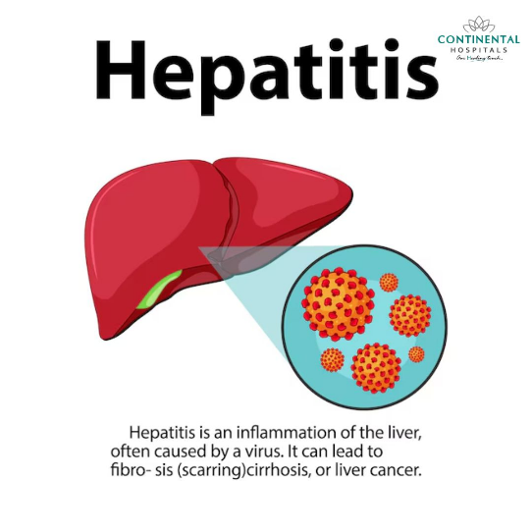***Treatment:* Supportive care, including hydration, nutritional support, and symptom management (antipyretics for fever, rest).
  + *Severe Cases:* Rare cases of acute liver failure may require liver transplantation.
* **Hepatitis B (HBV):**
  + *Acute HBV:* Supportive care as most acute infections are self-limiting.
  + *Chronic HBV:* Long-term antiviral therapy to suppress viral replication and prevent complications.
    - ***Drugs:* Tenofovir, Entecavir, Pegylated Interferon-α.**
    - *Goals:* Reduce viral load, improve liver function, lower HCC risk.
  + *Emerging Therapies:* Capsid inhibitors and RNA interference agents under investigation.
* **Hepatitis C (HCV):**
  + *Standard Treatment:* Direct-acting antivirals (DAAs), offering >95% cure rates.
    - Examples: Sofosbuvir, Ledipasvir, Velpatasvir.
  + *Combination Therapy:* Tailored based on genotype and liver disease severity.
  + *Post-Treatment:* Long-term monitoring for HCC in cirrhotic patients.
* **Hepatitis D (HDV):**
  + *Challenges:* Limited therapeutic options.
  + *Treatment:* Pegylated interferon-α for viral suppression. Research into entry inhibitors (e.g., Bulevirtide) shows promise.
* **Hepatitis E (HEV):**
  + *Acute Cases:* Supportive care, as most infections are self-limiting.
  + *Chronic HEV:* Occurs in immunocompromised individuals; treated with ribavirin and reduced immunosuppressants.

**2. Cirrhosis**

* **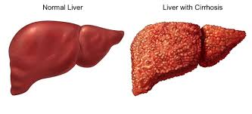***General Goals:* Slow disease progression, manage complications, improve quality of life.
* **Lifestyle Modifications:**
  + Absolute alcohol abstinence for alcohol-related cirrhosis.
  + Low-sodium diet to manage ascites.
* **Medications for Complications:**
  + *Ascites:* Diuretics (Spironolactone, Furosemide).
  + *Variceal Bleeding:* Non-selective beta-blockers (Propranolol) and endoscopic variceal ligation.
  + *Hepatic Encephalopathy:* Lactulose, Rifaximin to reduce ammonia levels.
* **Advanced Treatments:**
  + *Transjugular Intrahepatic Portosystemic Shunt (TIPS):* For refractory ascites or variceal bleeding.
  + *Liver Transplantation:* Definitive treatment for decompensated cirrhosis.

**3. Non-Alcoholic Fatty Liver Disease (NAFLD)**

* *Primary Focus:* Lifestyle interventions.
  + **Weight Loss:** A 7–10% weight reduction can significantly reduce steatosis and fibrosis.
  + **Dietary Changes:** Mediterranean diet, reduced sugar and saturated fat intake.
  + **Physical Activity:** Regular aerobic and resistance exercise.
* *Pharmacotherapy:*
  + **Vitamin E:** For non-diabetic patients with non-alcoholic steatohepatitis (NASH).
  + **Pioglitazone:** For patients with NASH and diabetes.
  + Investigational agents targeting fibrosis (e.g., FXR agonists, GLP-1 receptor agonists).
* *Monitoring and Long-Term Care:* Regular imaging and liver function tests to detect progression.

**4. Liver Cancer (Hepatocellular Carcinoma - HCC)**

* **Localized Tumors:**
  + *Surgical Resection:* Ideal for patients with good liver function and non-cirrhotic livers.
  + *Ablative Techniques:* Radiofrequency ablation (RFA) or microwave ablation for inoperable tumors.
* **Advanced Disease:**
  + *Systemic Therapies:*
    - Tyrosine kinase inhibitors (Sorafenib, Lenvatinib).
    - Immunotherapy (Atezolizumab combined with Bevacizumab).
  + *Chemoembolization:* Transarterial chemoembolization (TACE) for intermediate-stage disease.
  + *Selective Internal Radiation Therapy (SIRT):* Using yttrium-90 microspheres.
* **Curative Options:** Liver transplantation for select patients with early-stage HCC meeting Milan criteria.

**5. Autoimmune Hepatitis (AIH)**

* **Induction Therapy:**
  + Corticosteroids (Prednisone) to suppress immune-mediated liver damage.
* **Maintenance Therapy:**
  + Azathioprine combined with low-dose steroids.
  + Alternative immunosuppressants (e.g., Mycophenolate Mofetil) in steroid-intolerant patients.
* **Monitoring:** Lifelong immunosuppressive therapy often needed to prevent relapse.

**6. Hemochromatosis**

* *Treatment Focus:* Reducing iron overload.
  + **Phlebotomy:** Regular removal of blood to lower ferritin levels.
  + **Iron Chelators:** Deferoxamine for patients unable to tolerate phlebotomy.
* *Prevention of Complications:* Monitoring for cirrhosis and HCC.

**7. Wilson’s Disease**

* *Copper Chelation Therapy:*
  + Penicillamine or Trientine to enhance urinary copper excretion.
* *Zinc Supplementation:* To block intestinal copper absorption.
* *Dietary Restrictions:* Avoidance of copper-rich foods (e.g., shellfish, nuts).
* *Severe Cases:* Liver transplantation for patients with acute liver failure or advanced cirrhosis.

**8. Drug-Induced Liver Injury (DILI)**

* *Immediate Measures:* Discontinuation of the offending drug.
* *Supportive Care:* Fluid resuscitation, electrolyte balance.
* *Specific Antidotes:* N-acetylcysteine (NAC) for acetaminophen toxicity.
* *Severe Cases:* Early evaluation for liver transplantation.

**Emerging Therapies in Hepatic Disease Management**

* **Gene Therapy:** Promising for inherited liver diseases like Wilson’s disease and Hemophilia.
* **Stem Cell Therapy:** Potential to regenerate damaged liver tissue.
* **Targeted Anti-Fibrotic Drugs:** Therapies aimed at halting or reversing fibrosis (e.g., LOXL2 inhibitors).
* **Microbiome-Based Interventions:** Modulating gut-liver axis to influence disease progression.

**2.3 Risk Factors**

* Excessive alcohol consumption.
* Viral infections (HBV, HCV).
* Obesity and metabolic syndrome.
* Genetic predispositions and environmental toxins.

**3. Pathophysiology of Hepatic Diseases**

**3.1 Cellular and Molecular Mechanisms of Liver Damage**

The liver’s response to injury includes inflammation, oxidative stress, and fibrosis.

* **Inflammation:** Initiated by immune responses to pathogens or toxic substances, resulting in hepatocyte damage.
* **Oxidative Stress:** Excess reactive oxygen species (ROS) lead to lipid peroxidation and DNA damage.
* **Fibrosis:** Activation of hepatic stellate cells produces collagen, leading to scarring.

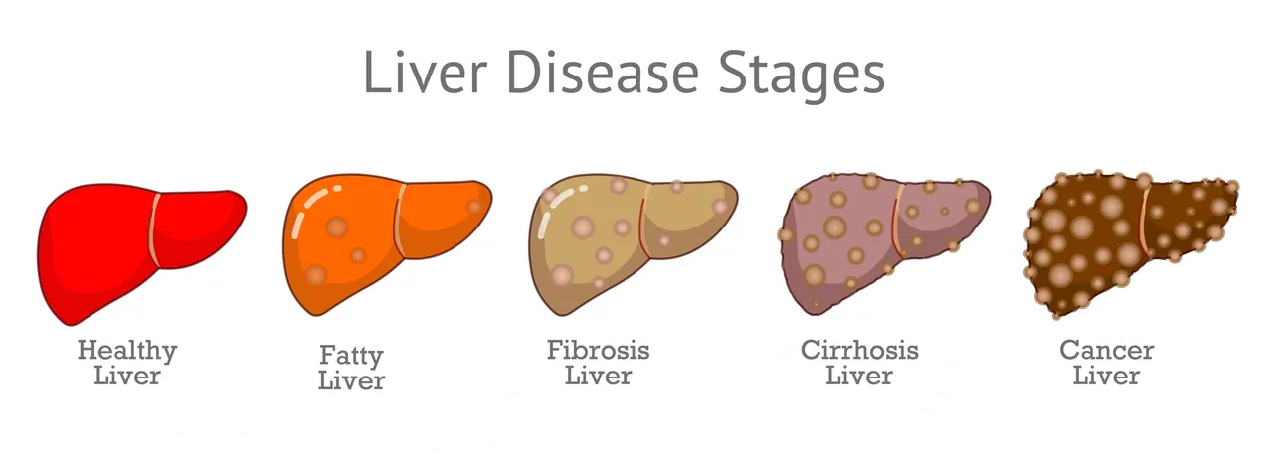**3.2 Progression of Liver Damage**

The progression of liver damage typically follows these stages:

1. **Steatosis:** Fat accumulation within hepatocytes, often reversible.
2. **Fibrosis:** Persistent damage leads to scar formation.
3. **Cirrhosis:** Extensive scarring disrupts normal liver architecture.
4. **Hepatic Failure:** Loss of liver function, leading to life-threatening complications.

Complications include:

* **Portal Hypertension:** Increased pressure in the portal vein.
* **Hepatic Encephalopathy:** Neurocognitive dysfunction due to toxin accumulation.
* **Coagulopathy:** Impaired synthesis of clotting factors.

**4. Diagnosis of Hepatic Diseases**

**4.1 Clinical Presentations and Symptoms**

Symptoms vary based on the type and stage of liver disease and include:

* Jaundice (yellowing of the skin and eyes).
* Fatigue and weakness.
* Abdominal pain and swelling (ascites).
* Unexplained weight loss.
* Dark urine and pale stools.

**4.2 Diagnostic Approaches**

**Laboratory Tests**

* **Liver Function Tests (LFTs):** Assess levels of alanine aminotransferase (ALT), aspartate aminotransferase (AST), bilirubin, and albumin.
* **Serological Markers:** Detect viral hepatitis and autoimmune liver diseases.

**Imaging Studies**

* **Ultrasound:** Initial imaging for liver abnormalities.
* **CT and MRI:** Detailed assessment of liver structure and tumors.
* **FibroScan:** Non-invasive assessment of liver fibrosis.

**Biopsy**

Liver biopsy remains the gold standard for diagnosing liver fibrosis and certain liver conditions.

**4.3 Emerging Diagnostic Technologies**

* Biomarkers for early detection of fibrosis.
* Advanced imaging modalities for real-time liver assessment.

**5. Management of Hepatic Diseases**

**5.1 General Management Principles**

* Lifestyle modifications: Balanced diet, regular exercise, and alcohol cessation.
* Weight loss in obese patients to manage NAFLD.

**5.2 Pharmacological Treatments**

* **Antivirals:** For HBV (e.g., tenofovir, entecavir) and HCV (e.g., direct-acting antivirals like sofosbuvir).
* **Anti-fibrotic Agents:** Emerging therapies targeting fibrosis.
* **Supportive Care:** Diuretics for ascites, lactulose for encephalopathy.

**5.3 Surgical Interventions**

* **Liver Transplantation:** The definitive treatment for end-stage liver disease. Challenges include donor shortages and immunosuppression.
* **Other Procedures:** Shunts for portal hypertension and resection for HCC.

**5.4 Disease-Specific Management**

* **Hepatitis:** Vaccination and antiviral treatments to prevent progression.
* **Cirrhosis:** Addressing complications like varices and infections.
* **NAFLD:** Lifestyle changes and potential drug therapies under investigation.
* **Liver Cancer:** Options include surgery, chemotherapy, immunotherapy, and ablation.

**5.5 Emerging Therapies**

* Gene therapy and RNA-based treatments.
* Stem cell-based regenerative medicine.
* Microbiome modulation.

**6. Prevention and Public Health Perspectives**

**6.1 Preventive Strategies**

* Vaccinations for HAV and HBV.
* Public education on reducing alcohol and managing obesity.

**6.2 Screening Programs**

* Targeted screening for high-risk groups, including those with HBV/HCV.
* Surveillance for HCC in cirrhotic patients.

**6.3 Health Policies**

* WHO initiatives to eliminate viral hepatitis by 2030.
* Policies promoting organ donation and equitable access to treatments.

**7. Challenges in Hepatic Disease Management**

* **Healthcare Disparities:** Limited access to diagnostic tools and treatments in low-resource settings.
* **Drug Resistance:** Emergence of resistant viral strains in chronic hepatitis.
* **Organ Shortage:** Inequities in liver transplantation.
* **Rising Incidence of NAFLD:** Linked to obesity and sedentary lifestyles.

**Conclusion**

Hepatic diseases represent a significant global health challenge, requiring a comprehensive approach to management. Advances in diagnostic tools and treatments, along with public health interventions, have improved outcomes for many patients. However, challenges such as healthcare disparities, organ shortages, and the rising prevalence of metabolic-related liver diseases emphasize the need for continued research and innovation. Preventive measures, including vaccination and lifestyle interventions, remain key to reducing the burden of liver diseases. Collaborative efforts from healthcare providers, policymakers, and researchers are essential to address this complex health issue effectively.

**References**

1. European Association for the Study of the Liver (EASL). "EASL Clinical Practice Guidelines on Hepatitis B and C." *Journal of Hepatology*, 2021.
2. World Health Organization (WHO). "Global Hepatitis Report 2022." Accessed at: [WHO website](https://www.who.int/hepatitis).
3. Chalasani, N., et al. "Nonalcoholic fatty liver disease: Pathogenesis, diagnosis, and treatment." *Hepatology*, 2021.
4. Friedman, S. L. "Liver fibrosis – From bench to bedside." *Journal of Hepatology*, 2020.
5. Singal, A. G., Lampertico, P., and Nahon, P. "Epidemiology and surveillance of hepatocellular carcinoma: New trends." *Journal of Hepatology*, 2021.
6. American Association for the Study of Liver Diseases (AASLD). "Guidelines for the Management of Cirrhosis." *Hepatology*, 2020.
7. Patel, V. C., et al. "Management of acute-on-chronic liver failure in critically ill patients." *Current Opinion in Critical Care*, 2021.
8. WHO. "Vaccination coverage and the prevention of hepatitis A and B." 2021.
9. Garcia-Tsao, G., et al. "Management of portal hypertension in cirrhosis: An update." *Hepatology*, 2022.
10. Younossi, Z. M., et al. "Global burden of NAFLD and NASH: trends and implications." *Nature Reviews Gastroenterology & Hepatology*, 2021.